|  |  |  |  |  |
| --- | --- | --- | --- | --- |
| Produto | Designação | Preço Unitário | Qtd. | Total |
|  | **Mini Projector Portátil Multimédia Para Ipod e Iphone** | 364.60 USD  36.460,00 AKZ | 1 | 364.60 USD  36.460,00 AKZ |
| 236.57 USD  23.657,00 AKZ | 5 | 1.182,89 USD  118.289,00 AKZ |
| C:\Users\Célio Garcia\BCCL\Acessórios de Ipad e Iphone\Projector\MG-50-main-1_910.jpg | **Epson MegaPlex MG-50 520p 3LCD**  **Projector para Ipad e Iphone** | 1.223,51 USD  122.351,00 AKZ | 1 | 1.223,51 USD  122.351,00 AKZ |
| 1154,65 USD  115.465,00 AKZ | 2 | 2.309,30 USD  230.930,00 AKZ |

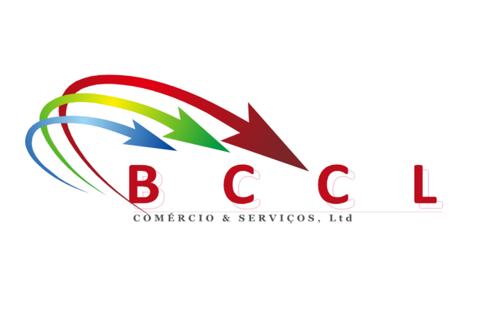

**BCCL – COMÉRCIO & SERVIÇOS, LDA**

**Telefones: (+244) 921785735 / (+244) 923501888**

**/ (+244) 923336431 / (+244) 923408033**

**E-mail:** [**informatica@bccl-ao.com**](mailto:informatica@bccl-ao.com)

**Web Site:** [**www.bccl-ao.com**](http://www.bccl-ao.com)